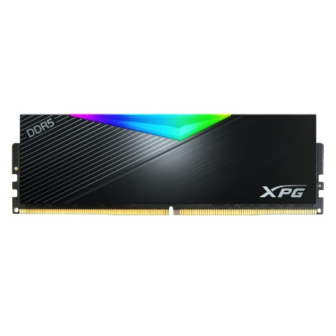

Inner

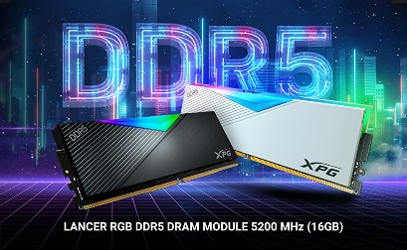

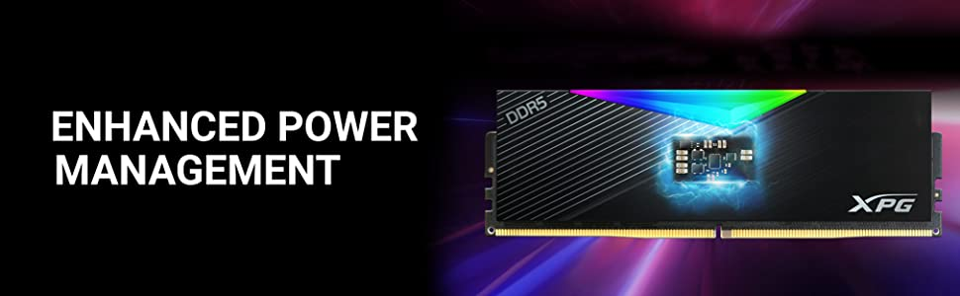

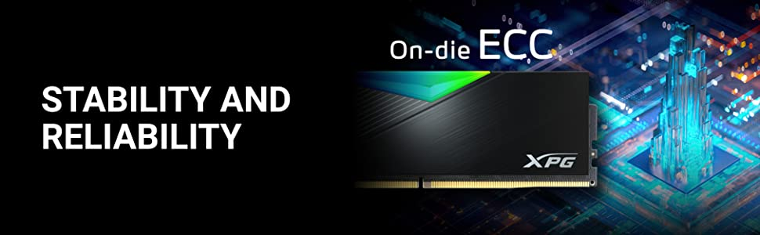

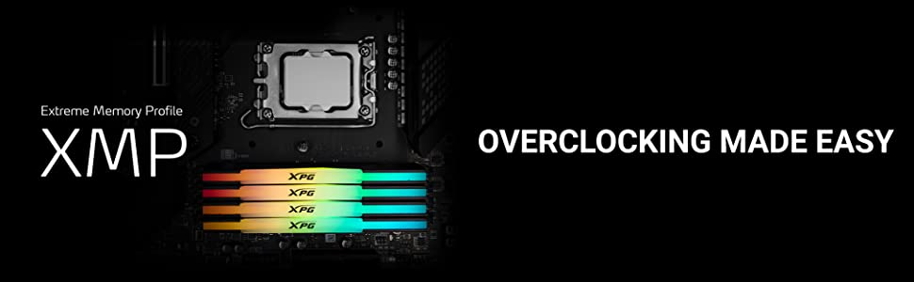

ADATA XPG Lancer RGB 16GB (1\*16 GB) DDR5 6000 MHz U-DIMM Desktop Memory RAM - AX5U6000C4016G-CLARBK

-50% ₹12,500.00₹12,500.00

M.R.P.: ₹25,000.00₹25,000.00

Product Description

* 16 GB (1 x 16GB) DDR5 RAM
* Form Factor : U-DIMM
* Speeds : 5200, 6000MT/s
* Operating Voltage : 1.25V, 1.35V ; Operating Temperature : 0°C to 85°C
* Dimensions (L x W x H) 133.35 x 40 x 8mm